34.107: a)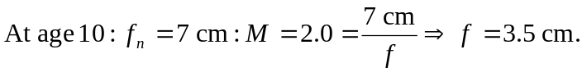
b)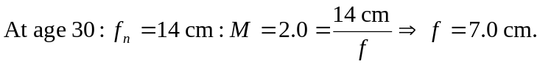
c)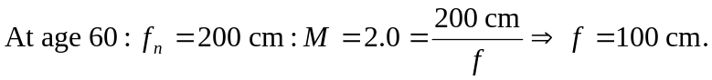
d) If the 2.8 cm focal length lens is used by the 60-year old, then 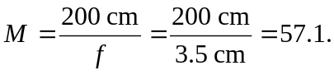
e) This does not mean that the older viewer sees a more magnified image. The object is over 28 times further away from the 60-year old, which is exactly the ratio needed to result in the magnification of 2.0 as seen by the 10-year old.

